Online Exam System with Randomized Questions and Result Analytics:

An e-assessment system that dynamically generates unique question sets from a pool per

student. Questions are tagged by difficulty, topic, and type (MCQ, True/False). Real-time

monitoring tracks time spent on each question and behavioral flags (like rapid switching). After

submission, the system produces detailed reports with graphs on strong and weak areas,

comparing students’ performance anonymously.

**Entities:**

1. Student
2. Exam
3. QuestionSet
4. Question
5. Answer
6. AnswerSet
7. Result
8. Report

**ERD:**

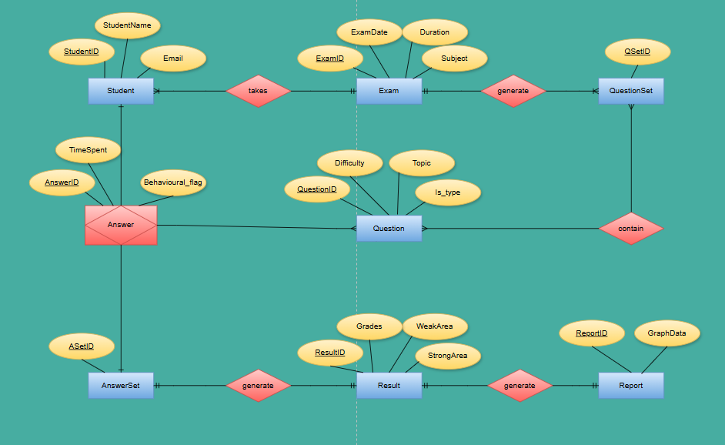

**Assumptions:**

* One student can take one and only one exam (at a time).
* An exam can be taken by one or more students (at a time).
* An exam can have one or more question set.
* A question set belong to one and only one exam.
* A student can answer many questions.
* An answerset can generate one and only one result and vice versa.
* A result can generate one and only one report and vice versa.

**Tables:**

Student (StudentID, StudentName, Email)

PK=StudentID

Exam (ExamID, Date, Duration, Subject, StudentID)

PK=ExamID

QuestionSet (QSetID, ExamID)

PK=SetID

FK1=ExamID

Question (QuestionID, QSetID, Topic, Difficulty, is-type)

PK=QuestionID

FK=SetID

QuestionSet_Question (SetID, QuestionID)

Answer (AnswerID, QuestionID, TimeSpent, BehavioralFlag)

PK=AnswerID

FK=QuestionID

AnswerSet (ASetID, AnswerID)

PK= ASetID

FK= AnswerID

Result (ResultID, StudentID, ExamID, ASetID, Grade, WeakArea, StrongArea)

PK= ResultID

FK= StudentID, ExamID, ASetID

Report (ReportID, ResultID, GraphData)

PK= ReportID

FK= ResultID